|  |  |  |  |  |
| --- | --- | --- | --- | --- |
|  |  | | |  |
|  |  | | |  |
|  | My Seat Space  <<Item>>  (F003519) | | |  |
|  |  | | |  |
| Document Type | **Feature Document (FD)** | | |  |
| Template Version | **6.0b / FFSD 7.1** | | |  |
| SysML Report Template Version | **O Beta (9/27/2019)** | | |  |
| Document ID | **ffst01.10_featuredocument_sysmlreporttemplate** | | |  |
| Document Location |  | | |  |
| Document Owner | Vaughn, Neil. | | |  |
| Document Revision | **FD0** | | |  |
| Document Status | **Draft** | | |  |
| Date Issued | **2020-10-06** | | |  |
| Date Revised | **2020-10-06** | | |  |
| Document Classification | GIS1 Item Number: | **27.60/35** | |  |
| GIS2 Classification: | **Confidential** | |
|  | | | | |
|  | | | | |
| Document Approval | | | | |
| Person | Role | | Email Confirmation | Date |
|  |  | |  |  |
|  |  | |  |  |

**Auto-Generated by MagicDraw**

Printed Copies Are Uncontrolled

# Disclaimer

**This document contains Ford Motor Company Confidential information. Disclosure of the information contained in any portion of this document is not permitted without the expressed, written consent of a duly authorized representative of Ford Motor Company, Dearborn, Michigan, U.S.A.**

**Copyright, Ó 2016 Ford Motor Company**

This document contains information developed and accumulated by and for FORD MOTOR COMPANY. As such, it is a proprietary document, which, if disseminated to unauthorized persons, would provide others with restricted information, data, or procedures not otherwise available, exposing the FORD MOTOR COMPANY to potential harm.

Employees and suppliers having custody of this specification or authorized to use it must be cognizant of its proprietary nature and ensure that the information herein is not made available to unauthorized persons.

FORD MOTOR COMPANY reserves the right to protect this work as an unpublished copyrighted work in the event of an inadvertent or deliberate unauthorized publication. FORD MOTOR COMPANY also reserves its rights under copyright laws to protect this work as a published work.

This document or portions thereof shall not be distributed outside FORD MOTOR COMPANY without prior written consent. Refer all questions concerning disclosure to the author(s) or to any duly authorized representative of Ford Motor Company.

# Contents

1.1.2 Decomposition of Functional Safety Requirement 13

Disclaimer 22

Contents 23

2 Introduction 26

2.1 Document Purpose 26

2.2 Document Scope 26

2.3 Document Audience 26

2.3.1 Stakeholder List 26

2.4 Document Organization 26

2.4.1 Document Context 26

2.4.2 Document Structure 27

2.5 Document Conventions 27

2.5.1 Requirements Templates 27

3 Feature Overview 28

3.1 Purpose and Description of Feature 28

3.2 Feature Variants 28

3.2.1 Regions & Markets 29

3.3 Input Requirements 29

3.3.1 Legal Requirements 30

3.3.2 Trustmark Requirements 30

3.3.3 Industry Standards 30

3.3.4 Attribute Requirements 30

3.4 Lessons Learned 30

3.5 Assumptions 31

3.6 References 31

3.6.1 Ford Documents 32

3.6.2 External Documents and Publications 32

3.7 Glossary 33

3.7.1 Parameters / Values 33

4 Feature Context 34

4.1 Feature Context Diagram 34

4.2 List of Influences 34

5 Feature Modeling 36

5.1 Operation Modes and States 36

5.2 Use Cases 38

5.2.1 Use Case Diagram 38

5.2.2 Actors 39

5.2.3 Use Case Descriptions 39

5.3 Driving and Operation Scenarios 43

5.4 Decision Tables 45

6 Feature Requirements 46

6.1 Functional Requirements 46

6.1.1 Error Handling 47

6.2 Non-Functional Requirements 47

6.2.1 Safety 47

6.2.2 Security 47

6.2.3 Reliability 47

6.3 HMI Requirements 47

6.4 Other Requirements 48

6.4.1 Design Requirements 48

6.4.2 Manufacturing Requirements 48

6.4.3 Service Requirements 48

6.4.4 After Sales Requirements 48

6.4.5 Process Requirements 48

6.4.6 Uncategorized Requirements 49

7 Functional Safety 50

7.1 System Behaviors for HARA 50

7.2 Safety Assumptions 50

7.3 Safety Goals 51

7.4 Functional Safety Requirements 53

7.4.1 Safety Goal: 53

7.4.2 Derivation of Functional Safety Requirements on Assumptions 55

7.5 ASIL Decomposition of Functional Safety Requirements 56

8 Architecture 57

8.1 Functional Architecture 57

8.1.1 List of Functions 57

8.2 Logical Architecture 58

8.2.1 Logical Interfaces 59

9 Open Concerns 61

10 Revision History 62

11 Appendix 63

11.1 Definitions 63

11.2 Abbreviations 63

**List of Figures**

Figure 1. 12

Figure 2: 28

Figure 3: - 28

Figure 4: 34

Figure 5: 36

Figure 6: 38

Figure 7:  55

Figure 8: 57

Figure 9: 58

**List of Tables**

Table 1: Features described in this FD 26

Table 2: Feature Variants 29

Table 3: Regions & Markets 29

Table 4: Ford internal Documents 32

Table 5: Ford internal Documents *(not specified in SysML model)* 32

Table 6: External documents and publications 32

Table 7: External documents and publications *(not specified in SysML model)* 33

Table 8: Parameters / Values used in this document *(Not supported by MagicDraw report generation)* 33

Table 9: List of Influences 35

Table 10: Operation Modes and States on 36

Table 11: Transitions between Operation Modes and States on 38

Table 12: List of Actors 39

Table 13: System Behaviors for HARA 50

Table 14: Functional Safety Assumptions 51

Table 15: Functional Safety Goals 53

Table 16: List of Functions 58

Table 17: List of Functions on 58

Table 18: Feature Interactions 59

Table 19: Feature Interactions on 59

Table 20: Open Concerns *(Not supported by MagicDraw report generation)* 61

Table 21: Definitions used in this document 63

Table 22: Abbreviations used in this document 64

# Introduction

## Document Purpose

A Feature Document (FD) document specifies **what** the feature shall do and how it shall behave from customer perspective. It should also provide reasoning and background **why** we have the feature in the vehicle.

The FD also serves as an Item Definition as defined by ISO26262 for those features, which follow the Ford Functional Safety process.

To get more information about the concept of feature, function and component level abstraction refer to the [Ford RE Wiki](http://wiki.ford.com/display/RequirementsEngineering/Requirements+Engineering+for+SW+Enabled+Features). For details on the Ford Functional Safety (ISO26262) process refer to the [Ford Functional Safety Sharepoint](https://pd3.spt.ford.com/sites/GlobalFunctionalSafety/Pages/default.aspx).

## Document Scope

This Feature Document (FD) specifies the following features:

|  |  |  |  |
| --- | --- | --- | --- |
| **Feature ID** | **Feature Name** | **Owner** | **Reference** |
| F003519 | My Seat Space  (Program(s): ) | Vaughn, Neil. |  |

Table 1: Features described in this FD

## Document Audience

The FD is written by the feature owner of

Vaughn, Neil.

. All Stakeholders, i.e., all people who have a valid interest in the feature should read and, if possible, review the FD. It needs to be guaranteed, that all stakeholders have access to the currently valid version of the FD.

**#Hint:** The FD template has the IP Classification “Proprietary” by default. IP Classification “Confidential” might be required in some cases, e.g. by Ford Functional Safety.

### Stakeholder List

For the latest list of stakeholder of the feature and their influence refer to <Put VSEM Link here>.

**#Hint:** Refer to [Ford RE Wiki – Stakeholder List](http://wiki.ford.com/display/RequirementsEngineering/Stakeholder+Analysis) on how to create a stakeholder list. The stakeholder list should be stored in VSEM in the pseudo folder “General Data Artifacts” of the corresponding feature.

|  |  |  |  |  |
| --- | --- | --- | --- | --- |
| **Name** | **CDSID** | **Contact Info** | **Role** | **Stakeholder Group** |
| Akshay Dalvi | adalvi8 |  | Architect |  |
| Daniel Limon Balboa | dlimonba |  | FMA Coach |  |
| Fernanda Garza | mgarza22 | FoM MBSE Group | Modeler |  |
| Gary Godula | ggodula |  | FuSa Engineer |  |

## Document Organization

### Document Context

Refer to the [Specification Structure page](http://wiki.ford.com/display/RequirementsEngineering/Specification+templates) in the [Ford RE Wiki](http://wiki.ford.com/display/RequirementsEngineering/Requirements+Engineering+for+SW+Enabled+Features) to understand how the FD relates to other Ford Requirements Documents and Specifications.

### Document Structure

The structure of this document is explained below:

**Section 1** – Introduction how to use this document including responsibilities and requisite documents. Explains the terminology. Gives a clarification of the definitions, concepts and abbreviations used in the document.

**Section 2** – Feature Description. States briefly the background and the purpose of the feature, feature variants and corresponding regions and markets. Also includes input requirements, assumptions and constraints.

**Section 3** – Feature Context describes all external entities, which have an influence on the feature.

**Section 4** – Feature Modeling. Contains Use Case, Driving Scenarios, State Charts to describe the functional behavior of the feature.

**Section 5** – Safety. Lists System Behaviors and Safety Goals of the feature.

**Section 6** – Feature Requirements. Lists functional and non-functional requirements of the feature.

**Section 7** – Architecture. Shows the coarse architecture, which the feature requirements are deployed to. Describes the elements and the boundary of the feature as well as the decomposition and distribution of associated functions.

**Section 8** – List of Open Concerns

**Section 9** – Document Change History including a list of new or modified requirements. The requirements in this document are tagged, and this section contains different types of tables listing all, new, or changed requirements by their title and page no.

**Section 10** – Appendix

**#Hint:** All sections are mandatory, unless explicitly marked by the tag “#Classification” as “optional” or as applicable e.g. to certain domains like “Functional Safety”.

## Document Conventions

### Requirements Templates

Each requirement, use case or scenario in this specification shall follow the corresponding template given in the document template *Specification_Macros.dotm* at [RE Wiki - Specification Templates](http://wiki.ford.com/display/RequirementsEngineering/Specification+templates?src=contextnavpagetreemode).

#### Identification of requirements

#### Requirements Attributes

The templates provided by *Specification_Macros.dotm* define a list of attributes for each requirement. This helps to classify the requirement. The attributes are explained at [RE Wiki - Requirements Attributes](http://wiki.ford.com/display/RequirementsEngineering/Requirements+Attributes?src=contextnavpagetreemode).

## References

### Ford Documents

List here all Ford internal documents, which are directly related to the feature.

| **Reference** | **Title** | **Doc. ID** | **Document Location** | **Revision** |
| --- | --- | --- | --- | --- |
| Ford GIS Standard | Ford GIS Standard |  |  |  |

Table 4: Ford internal Documents

### External Documents and Publications

The list of external documents could include books, reports and online sources.

**#Hint:** You may refer to [IEEE Citation Reference](http://www.ieee.org/documents/ieeecitationref.pdf) on how to format a reference.

| **Reference** | **Document / Publication** | **Document Location** |
| --- | --- | --- |
| IEEE Std 1012-2004 IEEE Standard for Software Verification and Validation |  |  |
| ISO/IEC 19500-2:2003 | Information technology -- Open Distributed Processing -- Part 2 |  |
| UML Testing Profile (UTP), v1.2 |  |  |
| Wikipedia |  |  |

Table 6: External documents and publications

## Glossary

**#Hint**: Terms, concepts and abbreviations used in the document shall be defined and illustrated here. Note that changes to terms and/or concepts described in this section tend to cause major updates to this document.

The tables below have feature specific definitions and abbreviations. For additional, non-feature specific terms please refer to the [RE Glossary](http://wiki.ford.com/display/RequirementsEngineering/Glossary?src=contextnavpagetreemode)

See Appendix for Definitions and Abbreviations.

### Parameters / Values

| **Name** | **Description** | **Range / Resolution** |
| --- | --- | --- |

Table 8: Parameters / Values used in this document

# Feature Overview

## Purpose and Description of Feature

**#Hint:** Some descriptive text to explain the purpose and functionality of the feature.

Feature to improve each customers’ individual entertainment and communication experience. This is accomplished by giving customers an isolated immersive audio experience, enabling each occupant to listen to their own audio while minimizing distraction to others in the vehicle. This feature further enables in-car communication, private phone calls, media stream sharing, audio enhancements, seamless connectivity to Vehicle Streaming Platform, climate, seat and lighting controls.

1. Multiple simultaneous connections/controls

• System allows for per seat individual and personalized audio experiences.

• Audio and media streaming as well as private phone calls are contained to one seat without affecting others

• Chimes and prompts can be sent to the appropriate seat without interrupting the entire vehicle.

2. Media sharing and enhanced in-vehicle communication

• Allows for improved two-way row-to-row communication by amplifying occupant speech.

• Allows for one-way communication for driver announcements

• Users can share their media content with others in the vehicle

3. Realtime control inside the vehicle

• Allows control of personalized seat environment

• Climate, lighting and seat controls can be managed by an app on user’s phone (URC).

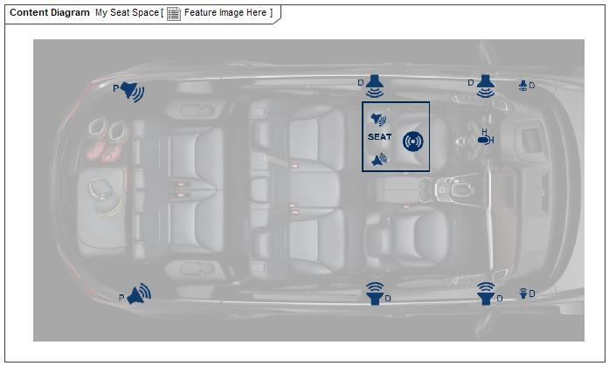

Figure 2: Feature Image Here

## Feature Variants

**#Hint:** Definitions for different variants of the feature (if applicable). Give each variant a descriptive name by which it can be referenced further on in the document. If no variant exists, state “No Feature Variants”.

The Variant Description should give a short informative text which describes the variants of the feature.

No Feature Variants specified.

### Regions & Markets

**#Hint:** Description of purpose and functionality of the feature. If there is no variant, give feature name in first column.

No Feature Variants specified.

## Input Requirements

**#Hint:** List all input requirements, which are relevant for the feature. Typically, attribute requirements, legal requirements as well as national and international standards have to be considered.

### Legal Requirements

* : Compliance with FMVSS101
  + The Feature shall comply with FMVSS101.

### Trustmark Requirements

No Trustmark Requirements specified.

### Industry Standards

* : ISO 26262
  + The system should be developed according to Ford's implementation of Functional Safety.

### Attribute Requirements

#### 14 : Example AR

## Lessons Learned

**#Hint:** Additional information and lessons learned from previous development or related features. A typical source for Lessons Learned is the FMA Quality History.

**#Functional Safety:** In context of Functional Safety Lessons Learned and similar information will be used to check the completeness of the Functional Safety Goals and assumptions in the Hazard Analysis and Risk Assessment (HARA).

**#Link:** [Ford Functional Safety Sharepoint](https://pd3.spt.ford.com/sites/GlobalFunctionalSafety/Pages/default.aspx)

No lessons learned specified.

## Assumptions

**#Classification**: Optional

**#Hint:** A list of known assumptions concerning the effects of the feature’s behavior on other features or elements (i.e., dependencies) as well as assumptions on the behavior expected by the feature (e.g. known limitations). During the course of the feature development most of those assumptions are typically either converted into actual requirements or discarded at some point – such that this chapter remains mostly empty. For assumptions, which are relevant for the Functional Safety process refer to chapter 7.2 “Safety Assumptions”

No Assumptions specified.

# Feature Context

## Feature Context Diagram

**#Hint:** High level diagram of feature interactions with the environment, people or other feature or other external entities.

**#Link:** [RE Wiki - Context Diagram](http://wiki.ford.com/pages/viewpage.action?pageId=107676234&src=contextnavpagetreemode)

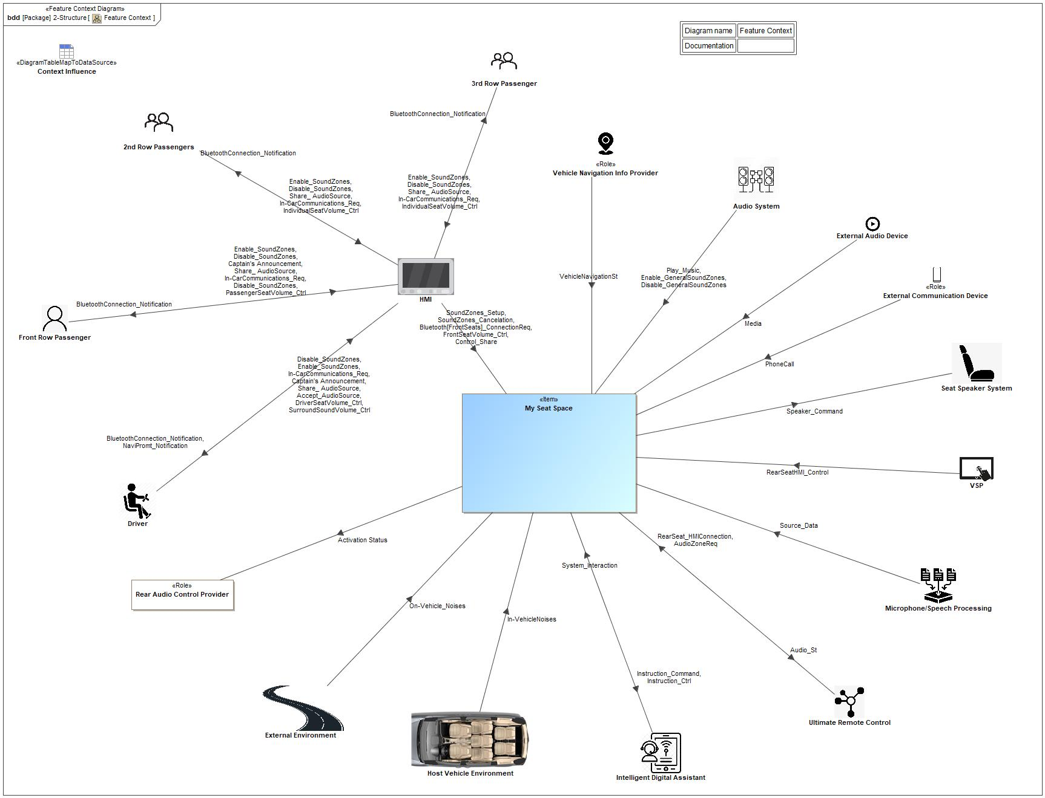

Figure 4: Feature Context

## List of Influences

|  |  |  |
| --- | --- | --- |
| **ID** | **External Entity** | **Influence Description** |
| Accept_AudioSource | Driver To HMI | Accept Audio source requests |
| Activation Status | My Seat Space To Rear Audio Control Provider | When MSS is activated the RACM will be locked out for the second row passengers |
| AudioZoneReq | Ultimate Remote Control To My Seat Space | Request to control audio |
| Audio_St | My Seat Space To Ultimate Remote Control | Simple and centralized way for all passengers to control of audio features in their seating zone |
| BluetoothConnection_Notification | HMI To 2nd Row Passengers | Bluetooth connection notification |
| HMI To 3rd Row Passenger | Bluetooth connection notification |
| HMI To Driver | Bluetooth connection notification |
| HMI To Front Row Passenger | Bluetooth connection notification |
| Bluetooth[FrontSeats]_ConnectionReq | HMI To My Seat Space | Request to pair bluetooth |
| Captain's Announcement | Driver To HMI | Enable communication |
| Front Row Passenger To HMI | Enable communication |
| Control_Share | HMI To My Seat Space | Share content to other available seats |
| Disable_GeneralSoundZones | Audio System To My Seat Space | Enable Do Not Disturb (DND) |
| Disable_SoundZones | 2nd Row Passengers To HMI | Disable sound on specific vehicle zone |
| 3rd Row Passenger To HMI | Disable sound on specific vehicle zone |
| Driver To HMI | Disable sound on specific vehicle zone |
| Front Row Passenger To HMI | Disable sound on specific vehicle zone |
| DriverSeatVolume_Ctrl | Driver To HMI | Adjust volume of driver seat |
| Enable_GeneralSoundZones | Audio System To My Seat Space | Disable DND |
| Enable_SoundZones | 2nd Row Passengers To HMI | Enable sound on specific vehicle zone |
| 3rd Row Passenger To HMI | Enable sound on specific vehicle zone |
| Driver To HMI | Enable sound on specific vehicle zone |
| Front Row Passenger To HMI | Enable sound on specific vehicle zone |
| FrontSeatVolume_Ctrl | HMI To My Seat Space | Control Front passenger seat volume |
| In-CarCommunications_Req | 2nd Row Passengers To HMI | Request for in car communication activation |
| 3rd Row Passenger To HMI | Request for in car communication activation |
| Driver To HMI | Request for in car communication activation |
| Front Row Passenger To HMI | Request for in car communication activation |
| In-VehicleNoises | Host Vehicle Environment To My Seat Space | -Bluetooth Interference  -Ignition System  -Seat Belt Status  -Door Ajar Status  -Other Occupants |
| IndividualSeatVolume_Ctrl | 2nd Row Passengers To HMI | Adjust individual seat zone volume |
| 3rd Row Passenger To HMI | Adjust individual seat zone volume |
| Instruction_Command | My Seat Space To Intelligent Digital Assistant | Control MSS via voice command |
| Instruction_Ctrl | My Seat Space To Intelligent Digital Assistant | Control MSS via voice command |
| Media | External Audio Device To My Seat Space | Audio or video |
| NaviPromt_Notification | HMI To Driver | Navigation prompt notification |
| On-Vehicle_Noises | External Environment To My Seat Space | -Android Auto/Apple CarPlay  -3rd Party Apps  -Bluetooth Interference |
| PassengerSeatVolume_Ctrl | Front Row Passenger To HMI | Adjust passenger seat volume |
| PhoneCall | External Communication Device To My Seat Space | Incoming/outgoing Phone call |
| Play_Music | Audio System To My Seat Space | Play Music |
| RearSeatHMI_Control | VSP To My Seat Space | For sharing/shared audio sources |
| RearSeat_HMIConnection | Ultimate Remote Control To My Seat Space | For sharing/shared audio sources |
| Share_ AudioSource | 2nd Row Passengers To HMI | Share audio source command |
| 3rd Row Passenger To HMI | Share audio source command |
| Driver To HMI | Share audio source command |
| Front Row Passenger To HMI | Share audio source command |
| SoundZones_Cancelation | HMI To My Seat Space | Enable DND |
| SoundZones_Setup | HMI To My Seat Space | Setup for each sound zone |
| Source_Data | Microphone/Speech Processing To My Seat Space | Provides information/audio source information delivered by microphone network (first row, second row, third row) |
| Speaker_Command | My Seat Space To Seat Speaker System | Enable speaker |
| SurroundSoundVolume_Ctrl | Driver To HMI | Control of the surround sound volume |
| System_Interaction | Intelligent Digital Assistant To My Seat Space | -Localized seat volume |
| VehicleNavigationSt | Vehicle Navigation Info Provider To My Seat Space | Vehicle's Navigation information |

Table 9: List of Influences

# Feature Modeling

## Operation Modes and States

**#Classification:** Optional (Mandatory for Functional Safety)

**#Link:** [RE Wiki – State Charts](http://wiki.ford.com/display/RequirementsEngineering/State+Charts?src=contextnavpagetreemode)

**#Hint:** State Charts are a popular means to express feature behavior in terms of states and modes. An advantage of this state machine like approach is that consistency can be easily verified.

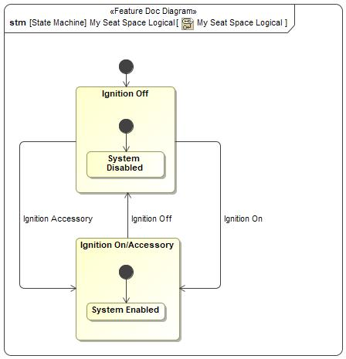

Figure 5: My Seat Space Logical

|  |  |  |
| --- | --- | --- |
| **State** | **Description** | **Requirements Reference** (optional) |
| Ignition Off | The system is off |  |
| Ignition On/Accessory | In this mode the systems waits for SYNC to boot up |  |
| System Disabled |  |  |
| System Enabled |  |  |

Table 10: Operation Modes and States on My Seat Space Logical

|  |  |  |  |  |
| --- | --- | --- | --- | --- |
| **Transition ID** | **Source** | **Destination** | **Description** | **Requirements Reference**  (optional) |
| T1 |  |  |  |  |
| T2 |  |  |  |  |
| T3 | Ignition Off | Ignition On/Accessory | Trigger signal: Ignition Accessory  SignalEvent Ignition Accessory |  |
| T4 |  |  |  |  |
| T5 | Ignition Off | Ignition On/Accessory | Trigger signal: Ignition On  SignalEvent Ignition On |  |
| T6 | Ignition On/Accessory | Ignition Off | Trigger signal: Ignition Off  SignalEvent Ignition Off |  |

Table 11: Transitions between Operation Modes and States on My Seat Space Logical

## Use Cases

**#Classification:** Optional

**#Link:** [RE Wiki – Use Cases](http://wiki.ford.com/display/RequirementsEngineering/Use+Cases+Overview?src=contextnavpagetreemodehttp://wiki.ford.com/display/RequirementsEngineering/Use+Cases?src=contextnavpagetreemode)

### Use Case Diagram

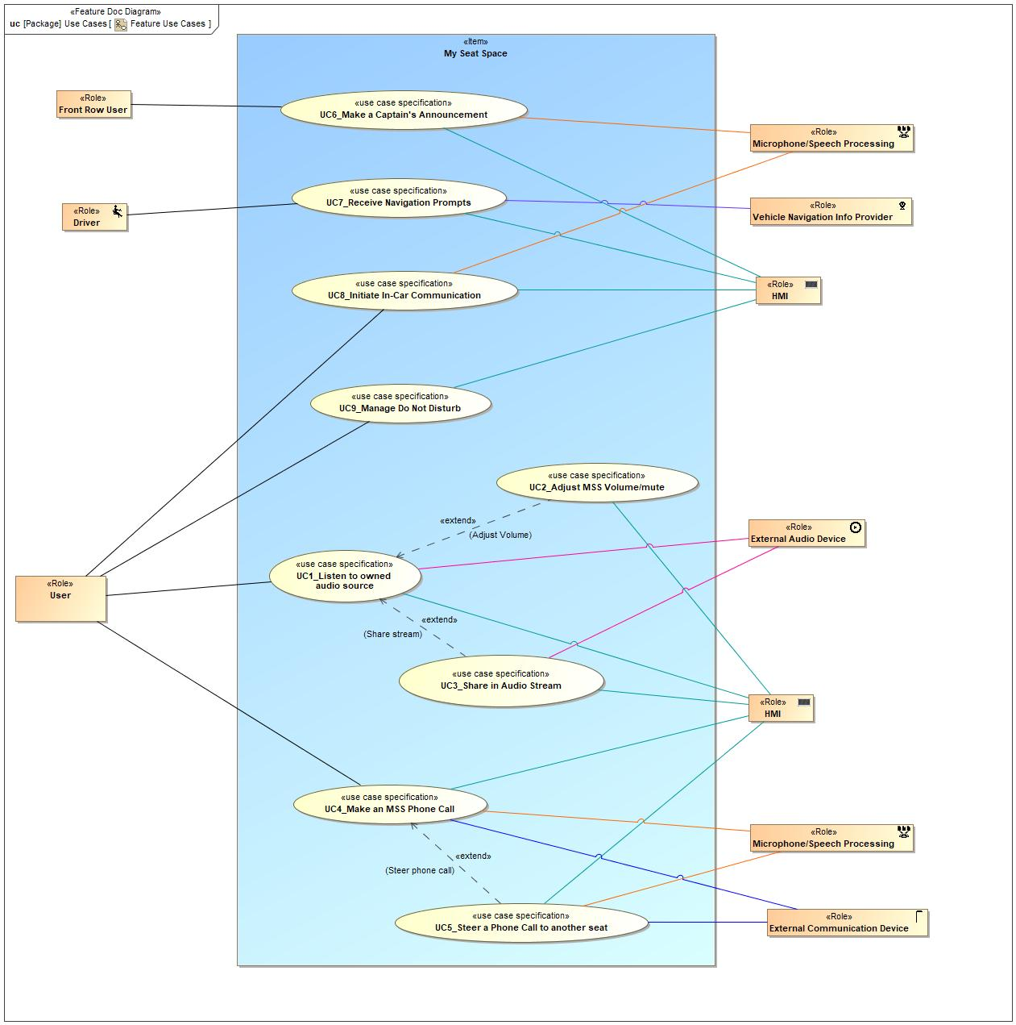

Figure 6: Feature Use Cases

### Actors

| **Actor** | **Description** |
| --- | --- |
| Driver | User seating on the driver's seat |
| External Audio Device | Any device that provides audio (ipod, mp3, etc) over BT |
| External Communication Device | Any device capable of cellular communication |
| Front Row User | User seating on 1st row (driver's or front passenger's seat) |
| HMI | HMI interface, may be SYNC, VSP, or brought in device. |
| Microphone/Speech Processing | Microphones on each seat |
| User | Vehicle occupants |
| Vehicle Navigation Info Provider | Entity providing Vehicle Navigation Data |

Table 12: List of Actors

### Use Case Descriptions

**#Classification:** Optional

UC6_Make a Captain's Announcement

|  |  |  |
| --- | --- | --- |
| **Actors** | Primary | Front Row User |
| Secondary | HMI |
| Secondary | Microphone/Speech Processing |
| **Subject** |  | My Seat Space |
| **Description** |  |  |
| **Preconditions** | PreC1 | Audio and Microphone system is available |
| PreC2 | HMI available |
| **Main Flow Description** |  | The driver or front row passenger wants to make an announcement to the entire vehicle. |
| **Main Flow** | M1 | Driver or front row passenger selects the captain’s announcement button in their HMI. |
| M2 | Audio in all seat zones is ducked. |
| M3 | A chime is played over seat zone speakers to indicate a captain’s announcement. |
| M4 | The driver or front row passenger speaks, and their voice is picked up by the front row microphones. |
| M5 | The driver’s or front row passenger’s voice message is played over all seat zone speaker. |
| M6 | Driver or front row passenger ends the captain’s announcement via HMI. |
| M7 | All seat zone audio returns to previous state. |
| **Postconditions** | PostC1 | None |

UC1_Listen to owned audio source

|  |  |  |
| --- | --- | --- |
| **Actors** | Primary | User |
| Secondary | External Audio Device |
| Secondary | HMI |
| **Subject** |  | My Seat Space |
| **Description** |  |  |
| **Preconditions** | PreC1 | Audio and Microphone system is available |
| PreC2 | Occupant’s seat audio system is paired to an external audio device via Bluetooth (eg. phone, tablet). |
| **Main Flow Description** |  | User wants to listen to audio from device on seat zone MSS speakers. |
| **Main Flow** | M1 | User selects desired audio source via device HMI. |
| M2 | User streams audio from device to own seat zone. |
| **Exceptional Flow Description** |  | E1. Switching from own audio to central audio. |
| **Exceptional Flow Steps** | E1 | E1.1 Any occupant currently listening to their own independent audio source sends a request through the HMI to switch source to the Central Audio System’s source. |
| E2 | E1.2 Central Audio System source streams to seat zone. |
| **Postconditions** | PostC1 | The audio is played via seat speakers only in the seat that is paired to the external audio device. Other seat zone audio systems are unaffected. |

UC5_Steer a Phone Call to another seat

|  |  |  |
| --- | --- | --- |
| **Actors** | Primary | User |
| Secondary | HMI |
| Secondary | External Communication Device |
| Secondary | Microphone/Speech Processing |
| **Subject** |  | My Seat Space |
| **Description** |  |  |
| **Preconditions** | PreC1 | Audio and Microphone system is available |
| PreC2 | User is currently in an active private telephone call on their phone/communication device. |
| PreC3 | User’s audio system is paired to an external mobile phone / communication device. |
| **Main Flow Description** |  | User that is currently in a phone call wants to share that phone call with another seat zone. |
| **Main Flow** | M1 | User initiates a transfer request through available HMI. |
| M2 | Selected user(s) receiver a share notification. |
| M3 | When accepted, the selected user’s audio (if applicable) is muted and the phone call audio is played over their MSS speakers. |
| M4 | Selected user’s microphone is activated and all users on the phone call are able to communicate on the call. |
| **Postconditions** | PostC1 | Once the call is completed all users’ seat zone settings are returned to their previous state. |

UC7_Receive Navigation Prompts

|  |  |  |
| --- | --- | --- |
| **Actors** | Primary | Driver |
| Secondary | HMI |
| Secondary | Vehicle Navigation Info Provider |
| **Subject** |  | My Seat Space |
| **Description** |  |  |
| **Preconditions** | PreC1 | Audio and Microphone system is available |
| PreC2 | MSS is activate in the driver’s seat |
| PreC3 | Vehicle Ignition is ON (Accessory Mode at minimum) |
| PreC4 | Vehicle Navigation is available and currently navigating to the requested destination |
| **Main Flow Description** |  | Driver wants to hear navigation prompts to only their seat. |
| **Main Flow** | M1 | While MSS is active for the driver’s seat, navigation prompts are sent only to the driver’s seat. |
| **Postconditions** | PostC1 | Driver receives navigation prompts. All other seat zones unaffected |

UC4_Make an MSS Phone Call

|  |  |  |
| --- | --- | --- |
| **Actors** | Primary | User |
| Secondary | External Communication Device |
| Secondary | HMI |
| Secondary | Microphone/Speech Processing |
| **Subject** |  | My Seat Space |
| **Description** |  |  |
| **Preconditions** | PreC1 | Audio and Microphone system is available |
| PreC2 | Occupant’s seat audio system is paired to an external communication device/mobile phone |
| **Main Flow Description** |  | User wants to make a phone call in their own seat zone. |
| **Main Flow** | M1 | User initiates the phone call from their external communication device/mobile phone. |
| **Alternative Flow Description** |  | User wants to receive a phone call in their own seat zone. |
| **Alternative Flow Steps** | A1 | User receives phone call on their external communication device/mobile phone |
| **Postconditions** | PostC1 | The communication channel is played via the seat speakers and the user’s voice is picked up by the seat microphone. Other seat audio systems are unaffected. |

UC3_Share in Audio Stream

|  |  |  |
| --- | --- | --- |
| **Actors** | Primary | User |
| Secondary | External Audio Device |
| Secondary | HMI |
| **Subject** |  | My Seat Space |
| **Description** |  |  |
| **Preconditions** | PreC1 | Audio system is available |
| PreC2 | User is currently streaming an audio source from their paired Bluetooth device. |
| **Main Flow Description** |  | User wants to share their own streaming audio with other seat zones. |
| **Main Flow** | M1 | User selects available seats to share audio with |
| M2 | User sends audio share request to selected seat zones |
| M3 | Selected users receive notification of share request from the originating user |
| M4 | If user(s) accept share request the shared audio plays over their seat zones speakers. |
| **Exceptional Flow Description** |  | E1. On M3 User(s) may choose to reject the audio share request |
| **Exceptional Flow Description** |  | E2. User wants to exit an active audio stream channel. |
| **Exceptional Flow Steps** | E1 | E1.1 When prompted user(s) rejects audio share request |
| E2 | E1.2 User(s) audio source remains unchanged |
| E3 | E2.1 Driver or any passenger in an active audio stream sharing channel wants to exit the channel. |
| E4 | E2.2 They initiate a request from their HMI. |
| E5 | E2.3 Initiating passenger’s seat audio is removed from the channel. |
| E6 | E2.4 The channel is closed if the exiting seat was the audio source or if there is only one seat left in the channel. |
| **Postconditions** | PostC1 | The audio is played via seat speakers in the originating as well as shared seat(s). Other seat audio systems are unaffected. |

UC9_Manage Do Not Disturb

|  |  |  |
| --- | --- | --- |
| **Actors** | Primary | User |
| Secondary | HMI |
| **Subject** |  | My Seat Space |
| **Description** |  |  |
| **Preconditions** | PreC1 | Audio and Microphone system is available |
| PreC2 | HMI is available |
| **Main Flow Description** |  | User wishes to activate Do Not Disturb (DND) for their seat. |
| **Main Flow** | M1 | User activates DND for their seat through a HMI. |
| **Alternative Flow Description** |  | A1. User wishes deactive Do Not Disturb (DND) for their seat |
| **Alternative Flow Description** |  | A2. Driver wishes to activate Do Not Disturb (DND) for someone else’s seat |
| **Alternative Flow Description** |  | A3. Driver wishes to deactivate Do Not Disturb (DND) for someone else’s seat |
| **Alternative Flow Steps** | A1 | A1.1 User deactivates DND for their seat through a HMI. |
| A2 | A2.1 User activates DND for someone elses' seat through a HMI |
| A3 | A3.1 User deactivates DND for someone elses' seat through a HMI |
| **Postconditions** | PostC1 | In-car seat communication or notifications to seats are allowed/blocked. |

UC2_Adjust MSS Volume/mute

|  |  |  |
| --- | --- | --- |
| **Actors** | Primary | User |
| Secondary | HMI |
| **Subject** |  | My Seat Space |
| **Description** |  |  |
| **Preconditions** | PreC1 | Audio and Microphone system is available |
| PreC2 | HMI is available |
| **Main Flow Description** |  | User adjusting the volume of their sound zone. |
| **Main Flow** | M1 | User requests change via HMI. |
| **Postconditions** | PostC1 | Other seat sound zones are unaffected. |
| PostC2 | The volume of the audio in the seat speakers is increased, decreased or muted as requested. |

UC8_Initiate In-Car Communication

|  |  |  |
| --- | --- | --- |
| **Actors** | Primary | User |
| Secondary | HMI |
| Secondary | Microphone/Speech Processing |
| **Subject** |  | My Seat Space |
| **Description** |  |  |
| **Preconditions** | PreC1 | Audio and Microphone system is available |
| PreC2 | HMI available |
| **Main Flow Description** |  | Any user in the vehicle wants to speak more easily to the other rows by activating ICC via their HMI. |
| **Main Flow** | M1 | User selects to activate ICC via their HMI. |
| M2 | All seat zone microphones and seats are activated for ICC. |
| M3 | Any user may speak and their seat zone microhone will pick up their speech. |
| M4 | Speech from any seat zone microphone is played to all other seat zone speakers. |
| **Exceptional Flow Description** |  | User wants to disable In Car Communication |
| **Exceptional Flow Steps** | E1 | User disabled In Car Communication via HMI |
| E2 | Seat zone audio is returned to previous state |
| **Postconditions** | PostC1 | Communication channels remain active. |

## Driving and Operation Scenarios

**#Classification:** Optional (Mandatory for Functional Safety)

**#Functional Safety:** Driving and operating scenarios which impact the functionality of the feature can be used to check, if the situation analysis in the HARA is complete

**#Link:** [RE Wiki – Driving Scenarios](http://wiki.ford.com/display/RequirementsEngineering/Driving+Scenarios?src=contextnavpagetreemode)

Additional Driving Scenario 1

Description of the scenario in the Documentation field on the Feature Scenario Diagram.

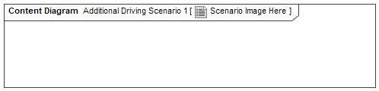

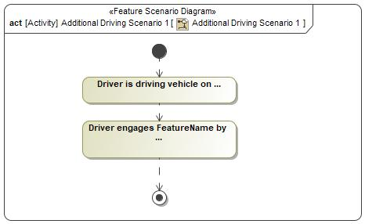

|  |  |
| --- | --- |
| **Flow of Actions** | |
| 1 | Driver is driving vehicle on ... |
| 2 | Driver engages FeatureName by ... |

UC1_Listen to owned audio source

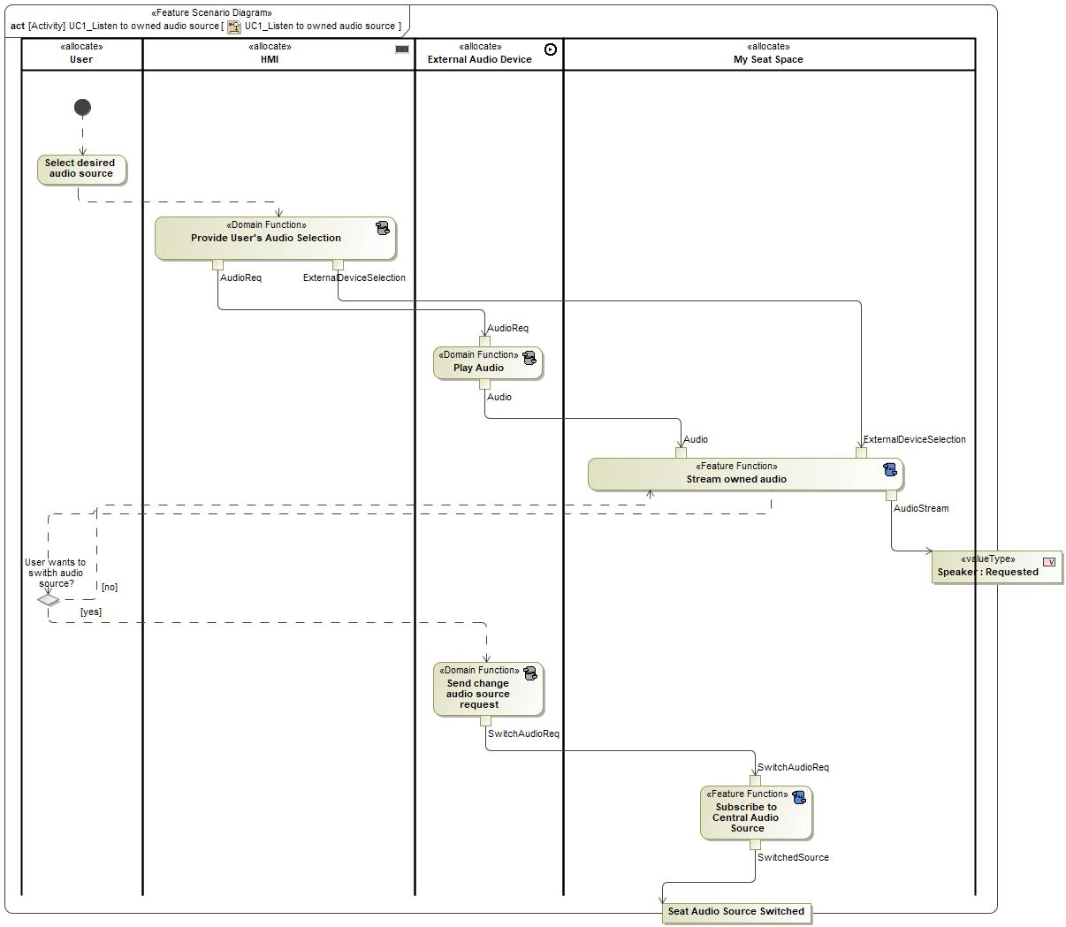

UC2_Adjust MSS Volume/mute

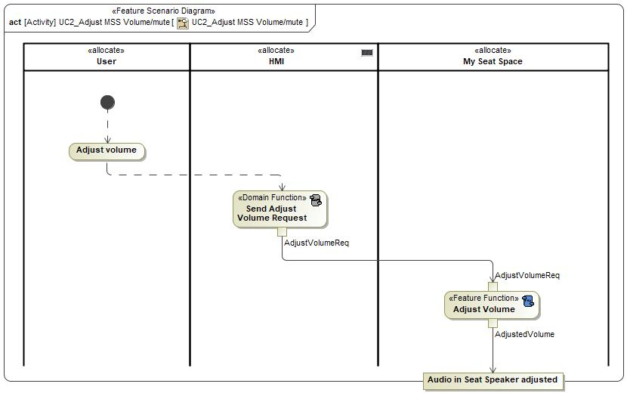

UC3_Share in Audio Stream

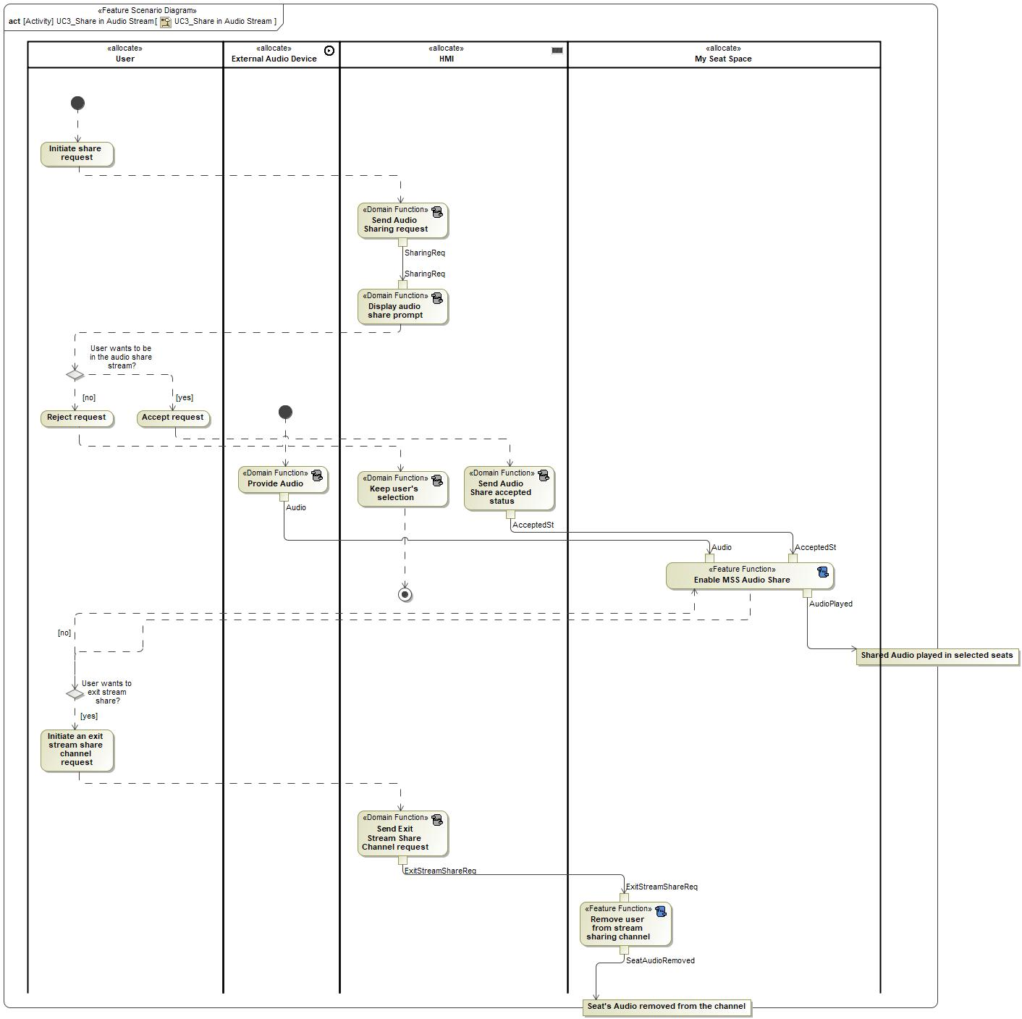

UC4_Make an MSS Phone Call

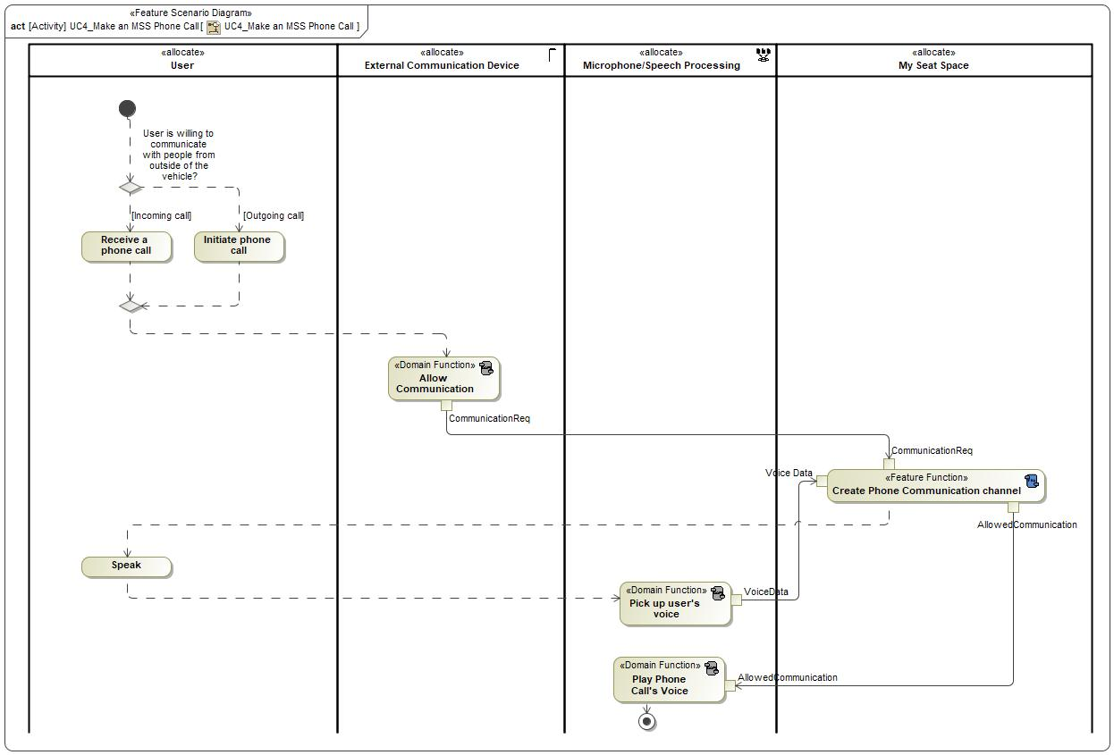

UC5_Steer a Phone Call to another seat

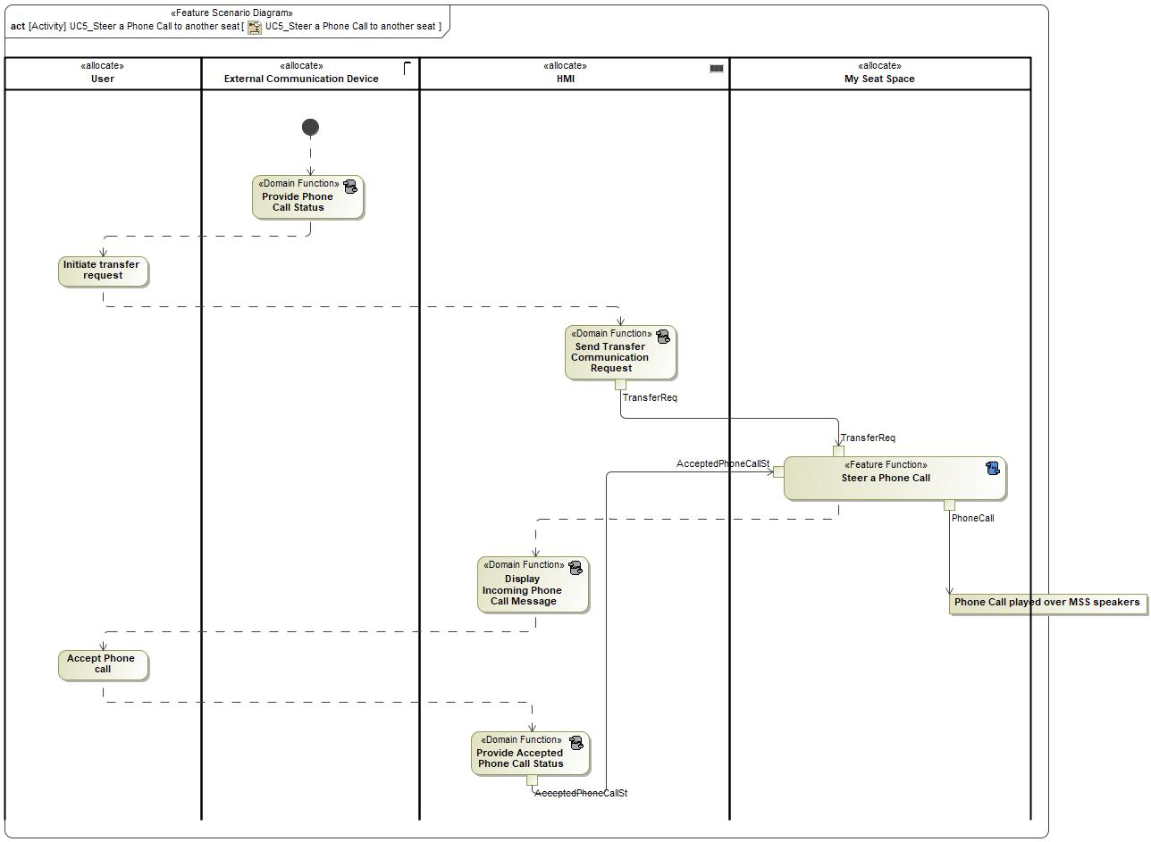

UC6_Make a Captain's Announcement

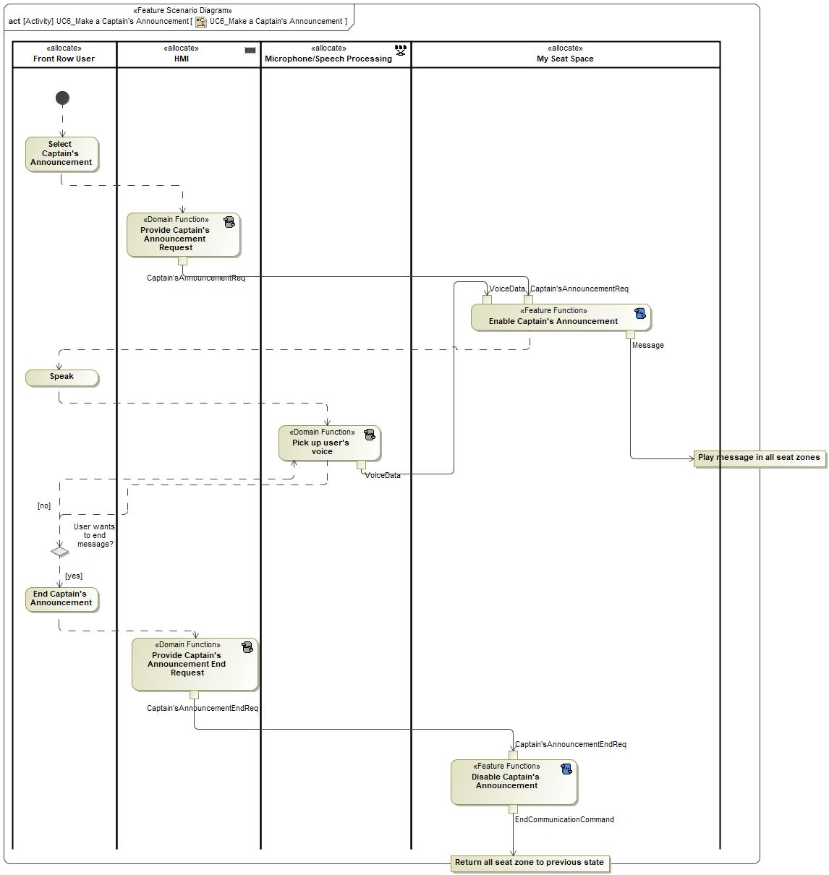

UC7_Receive Navigation Prompts

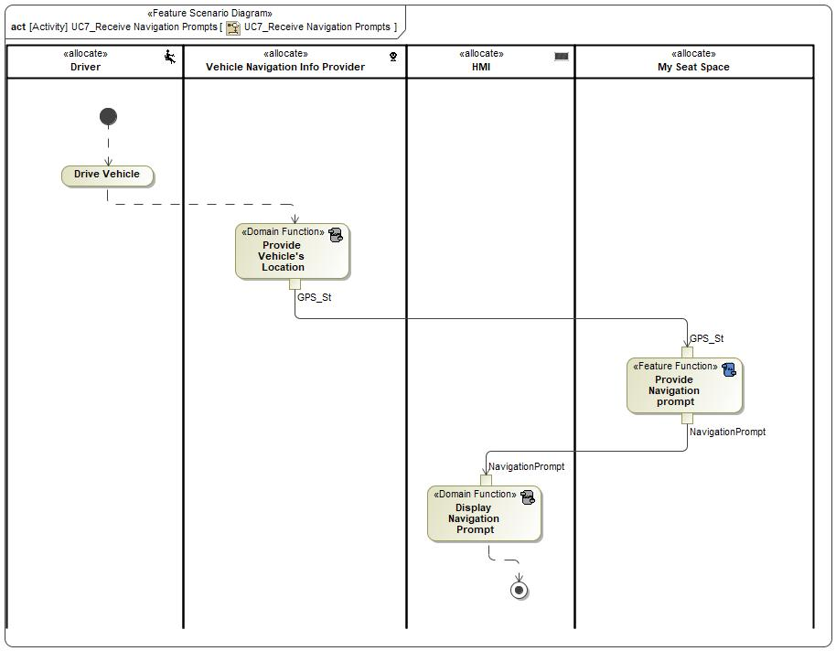

UC8_Initiate In-Car Communication

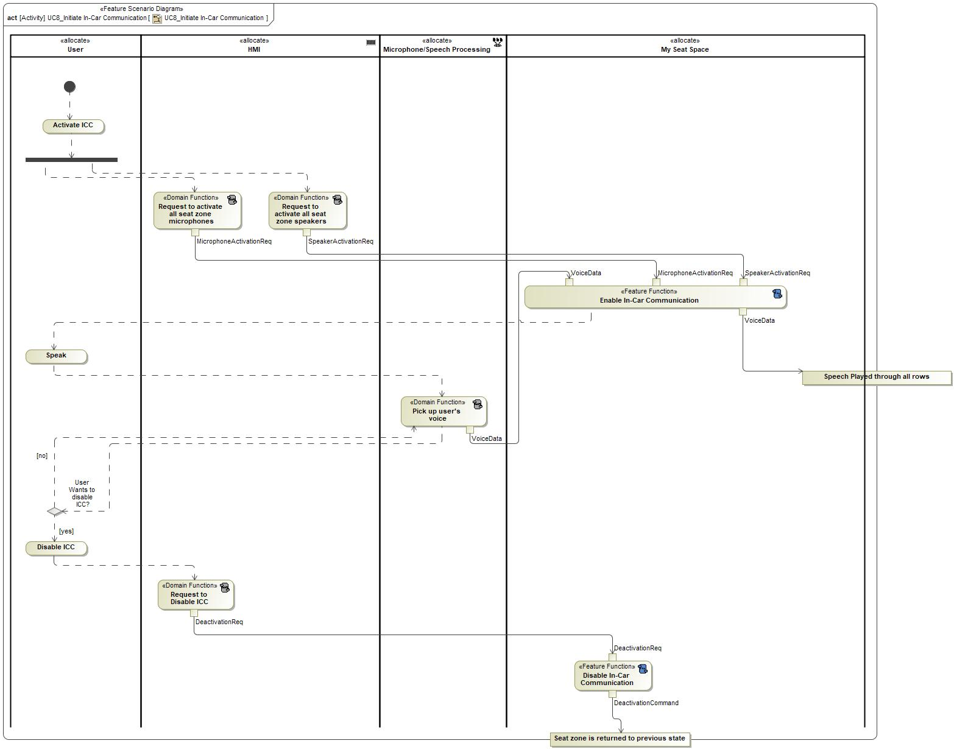

UC9_Manage Do Not Disturb

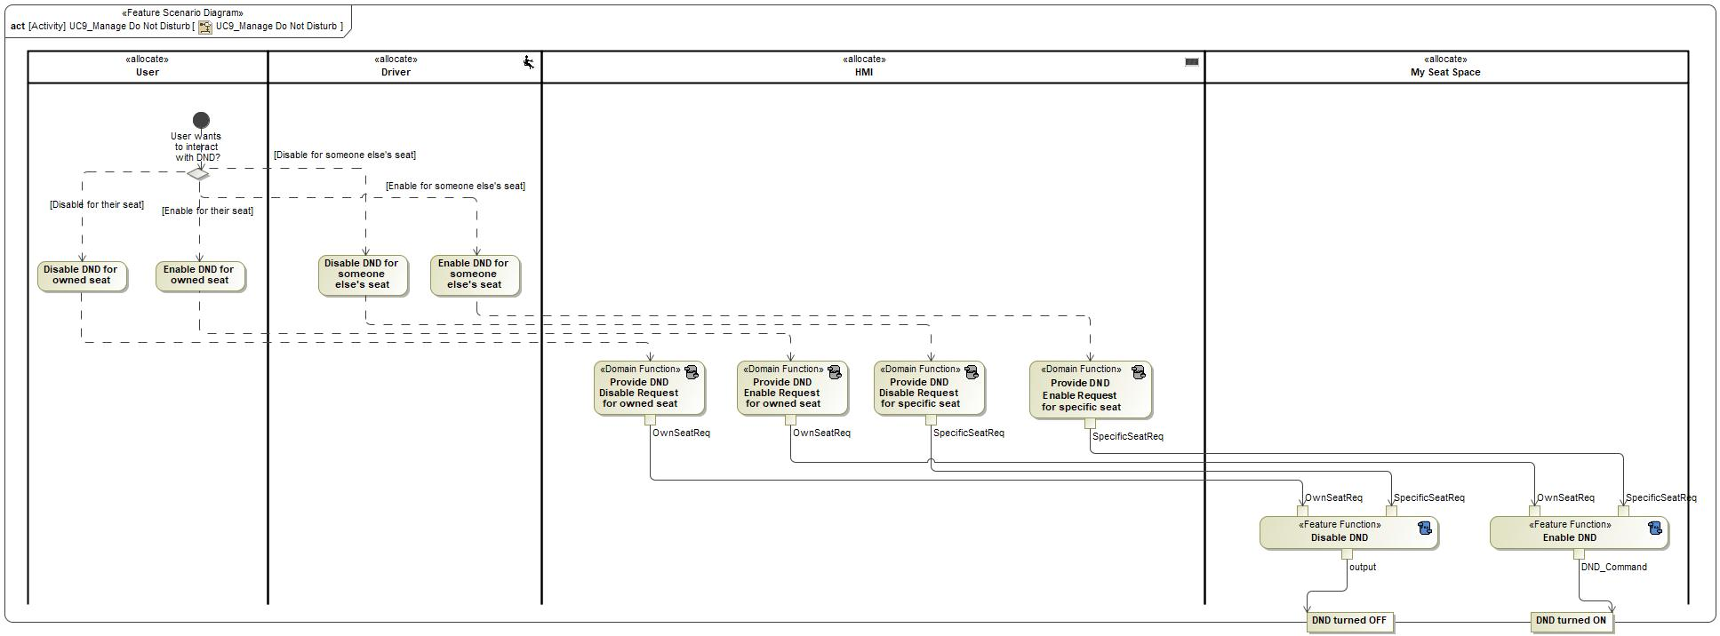

## Decision Tables

**#Classification:** Optional

**#Link:** [RE Wiki – Decision Tables](http://wiki.ford.com/display/RequirementsEngineering/Decision+Table).

**#Hint:** Use decision table, if behavior is not state based (in that case prefer state chart from ch. 5.1) and based purely on current inputs.

*Not supported by MagicDraw report generation.*

# Feature Requirements

**#Functional Safety:** In general, safety requirements are not listed here. However, it is possible that later in the development process, a non-safety requirement becomes a safety requirement. In such a case it may remain on this list.

**#Link:** [RE Wiki – How to write good requirements](http://wiki.ford.com/display/RequirementsEngineering/How+to+write+better+requirements?src=contextnavpagetreemode).

## Functional Requirements

Phone Calls 1.2

MSS shall allow user to share a phone call with other seat zones.

|  |  |  |  |  |  |  |  |
| --- | --- | --- | --- | --- | --- | --- | --- |
| Requirement ID: | | | | | | | |
| **Rationale** |  | | | | | | |
| **Acceptance Criteria** |  | | | | | | |
| **Notes** |  | | | | | | |
| **Source** |  | | | | | **Owner** |  |
| **Source Req.** |  | | | | | **V&V Method** |  |
| **Type** |  | | | **Priority** |  | **Status** | In-Progress |
| [Req. Template](http://wiki.ford.com/display/RequirementsEngineering/Requirements+Attributes) Version | | 6.0 | End of Requirement | | | | |

Phone Calls 1

MSS shall allow each sound zone to receive its own phone call.

|  |  |  |  |  |  |  |  |
| --- | --- | --- | --- | --- | --- | --- | --- |
| Requirement ID: | | | | | | | |
| **Rationale** |  | | | | | | |
| **Acceptance Criteria** |  | | | | | | |
| **Notes** |  | | | | | | |
| **Source** |  | | | | | **Owner** |  |
| **Source Req.** |  | | | | | **V&V Method** |  |
| **Type** |  | | | **Priority** |  | **Status** | In-Progress |
| [Req. Template](http://wiki.ford.com/display/RequirementsEngineering/Requirements+Attributes) Version | | 6.0 | End of Requirement | | | | |

Row to Row Communication1.1

MSS shall provide a means for users to be able to communicate with any other row effortlessly without changing their seating position.

|  |  |  |  |  |  |  |  |
| --- | --- | --- | --- | --- | --- | --- | --- |
| Requirement ID: | | | | | | | |
| **Rationale** |  | | | | | | |
| **Acceptance Criteria** |  | | | | | | |
| **Notes** |  | | | | | | |
| **Source** |  | | | | | **Owner** |  |
| **Source Req.** |  | | | | | **V&V Method** |  |
| **Type** |  | | | **Priority** |  | **Status** | In-Progress |
| [Req. Template](http://wiki.ford.com/display/RequirementsEngineering/Requirements+Attributes) Version | | 6.0 | End of Requirement | | | | |

Captain’s Announcement 1

When a captain’s announcement is made, MSS shall duck the volume of any media playing in each sound zone.

|  |  |  |  |  |  |  |  |
| --- | --- | --- | --- | --- | --- | --- | --- |
| Requirement ID: | | | | | | | |
| **Rationale** |  | | | | | | |
| **Acceptance Criteria** |  | | | | | | |
| **Notes** |  | | | | | | |
| **Source** |  | | | | | **Owner** |  |
| **Source Req.** |  | | | | | **V&V Method** |  |
| **Type** |  | | | **Priority** |  | **Status** | In-Progress |
| [Req. Template](http://wiki.ford.com/display/RequirementsEngineering/Requirements+Attributes) Version | | 6.0 | End of Requirement | | | | |

Row to Row Communication1.2

MSS shall allow users to activate and deactivate In-Car Communication.

|  |  |  |  |  |  |  |  |
| --- | --- | --- | --- | --- | --- | --- | --- |
| Requirement ID: | | | | | | | |
| **Rationale** |  | | | | | | |
| **Acceptance Criteria** |  | | | | | | |
| **Notes** |  | | | | | | |
| **Source** |  | | | | | **Owner** |  |
| **Source Req.** |  | | | | | **V&V Method** |  |
| **Type** |  | | | **Priority** |  | **Status** | In-Progress |
| [Req. Template](http://wiki.ford.com/display/RequirementsEngineering/Requirements+Attributes) Version | | 6.0 | End of Requirement | | | | |

Shared Media 1.1

MSS shall allow users listening to content from another sound zone to exit that audio stream.

|  |  |  |  |  |  |  |  |
| --- | --- | --- | --- | --- | --- | --- | --- |
| Requirement ID: | | | | | | | |
| **Rationale** |  | | | | | | |
| **Acceptance Criteria** |  | | | | | | |
| **Notes** |  | | | | | | |
| **Source** |  | | | | | **Owner** |  |
| **Source Req.** |  | | | | | **V&V Method** |  |
| **Type** |  | | | **Priority** |  | **Status** | In-Progress |
| [Req. Template](http://wiki.ford.com/display/RequirementsEngineering/Requirements+Attributes) Version | | 6.0 | End of Requirement | | | | |

Shared Media 1.2

MSS shall allow users to accept and listen to shared content.

|  |  |  |  |  |  |  |  |
| --- | --- | --- | --- | --- | --- | --- | --- |
| Requirement ID: | | | | | | | |
| **Rationale** |  | | | | | | |
| **Acceptance Criteria** |  | | | | | | |
| **Notes** |  | | | | | | |
| **Source** |  | | | | | **Owner** |  |
| **Source Req.** |  | | | | | **V&V Method** |  |
| **Type** |  | | | **Priority** |  | **Status** | In-Progress |
| [Req. Template](http://wiki.ford.com/display/RequirementsEngineering/Requirements+Attributes) Version | | 6.0 | End of Requirement | | | | |

Shared Media 1.3

MSS shall allow users to decline a shared content request.

|  |  |  |  |  |  |  |  |
| --- | --- | --- | --- | --- | --- | --- | --- |
| Requirement ID: | | | | | | | |
| **Rationale** |  | | | | | | |
| **Acceptance Criteria** |  | | | | | | |
| **Notes** |  | | | | | | |
| **Source** |  | | | | | **Owner** |  |
| **Source Req.** |  | | | | | **V&V Method** |  |
| **Type** |  | | | **Priority** |  | **Status** | In-Progress |
| [Req. Template](http://wiki.ford.com/display/RequirementsEngineering/Requirements+Attributes) Version | | 6.0 | End of Requirement | | | | |

MSS Audio 1

MSS shall support individual sound zones for each seat.

|  |  |  |  |  |  |  |  |
| --- | --- | --- | --- | --- | --- | --- | --- |
| Requirement ID: | | | | | | | |
| **Rationale** |  | | | | | | |
| **Acceptance Criteria** |  | | | | | | |
| **Notes** |  | | | | | | |
| **Source** |  | | | | | **Owner** |  |
| **Source Req.** |  | | | | | **V&V Method** |  |
| **Type** |  | | | **Priority** |  | **Status** | In-Progress |
| [Req. Template](http://wiki.ford.com/display/RequirementsEngineering/Requirements+Attributes) Version | | 6.0 | End of Requirement | | | | |

MSS Audio 1.1

MSS shall provide a means for a user to control their audio (volume, play/pause, etc).

|  |  |  |  |  |  |  |  |
| --- | --- | --- | --- | --- | --- | --- | --- |
| Requirement ID: | | | | | | | |
| **Rationale** |  | | | | | | |
| **Acceptance Criteria** |  | | | | | | |
| **Notes** |  | | | | | | |
| **Source** |  | | | | | **Owner** |  |
| **Source Req.** |  | | | | | **V&V Method** |  |
| **Type** |  | | | **Priority** |  | **Status** | In-Progress |
| [Req. Template](http://wiki.ford.com/display/RequirementsEngineering/Requirements+Attributes) Version | | 6.0 | End of Requirement | | | | |

Do Not Disturb

MSS shall allow a user to lock out in-car communication and media share requests in their sound zone.

|  |  |  |  |  |  |  |  |
| --- | --- | --- | --- | --- | --- | --- | --- |
| Requirement ID: | | | | | | | |
| **Rationale** |  | | | | | | |
| **Acceptance Criteria** |  | | | | | | |
| **Notes** |  | | | | | | |
| **Source** |  | | | | | **Owner** |  |
| **Source Req.** |  | | | | | **V&V Method** |  |
| **Type** |  | | | **Priority** |  | **Status** | In-Progress |
| [Req. Template](http://wiki.ford.com/display/RequirementsEngineering/Requirements+Attributes) Version | | 6.0 | End of Requirement | | | | |

Navigation Prompts

MSS shall send navigation prompts and alerts to only the driver’s seat zone.

|  |  |  |  |  |  |  |  |
| --- | --- | --- | --- | --- | --- | --- | --- |
| Requirement ID: | | | | | | | |
| **Rationale** |  | | | | | | |
| **Acceptance Criteria** |  | | | | | | |
| **Notes** |  | | | | | | |
| **Source** |  | | | | | **Owner** |  |
| **Source Req.** |  | | | | | **V&V Method** |  |
| **Type** |  | | | **Priority** |  | **Status** | In-Progress |
| [Req. Template](http://wiki.ford.com/display/RequirementsEngineering/Requirements+Attributes) Version | | 6.0 | End of Requirement | | | | |

Row to Row Communication 1

MSS shall allow users in the front and rear of the vehicle to be able to communicate back and forth effortlessly without raising their voice or changing their seating position.

|  |  |  |  |  |  |  |  |
| --- | --- | --- | --- | --- | --- | --- | --- |
| Requirement ID: | | | | | | | |
| **Rationale** |  | | | | | | |
| **Acceptance Criteria** |  | | | | | | |
| **Notes** |  | | | | | | |
| **Source** |  | | | | | **Owner** |  |
| **Source Req.** |  | | | | | **V&V Method** |  |
| **Type** |  | | | **Priority** |  | **Status** |  |
| [Req. Template](http://wiki.ford.com/display/RequirementsEngineering/Requirements+Attributes) Version | | 6.0 | End of Requirement | | | | |

Phone Calls 1.1

MSS shall provide a means for a user to make a phone call from their sound zone.

|  |  |  |  |  |  |  |  |
| --- | --- | --- | --- | --- | --- | --- | --- |
| Requirement ID: | | | | | | | |
| **Rationale** |  | | | | | | |
| **Acceptance Criteria** |  | | | | | | |
| **Notes** |  | | | | | | |
| **Source** |  | | | | | **Owner** |  |
| **Source Req.** |  | | | | | **V&V Method** |  |
| **Type** |  | | | **Priority** |  | **Status** | In-Progress |
| [Req. Template](http://wiki.ford.com/display/RequirementsEngineering/Requirements+Attributes) Version | | 6.0 | End of Requirement | | | | |

Captain's Announcement 1.1

MSS shall provide a means for an audible speech announcement to be made by the driver to all sound zones.

|  |  |  |  |  |  |  |  |
| --- | --- | --- | --- | --- | --- | --- | --- |
| Requirement ID: | | | | | | | |
| **Rationale** |  | | | | | | |
| **Acceptance Criteria** |  | | | | | | |
| **Notes** |  | | | | | | |
| **Source** |  | | | | | **Owner** |  |
| **Source Req.** |  | | | | | **V&V Method** |  |
| **Type** |  | | | **Priority** |  | **Status** | In-Progress |
| [Req. Template](http://wiki.ford.com/display/RequirementsEngineering/Requirements+Attributes) Version | | 6.0 | End of Requirement | | | | |

Shared Media 1

MSS shall allow user to share audio content from their external audio device to any other sound zone.

|  |  |  |  |  |  |  |  |
| --- | --- | --- | --- | --- | --- | --- | --- |
| Requirement ID: | | | | | | | |
| **Rationale** |  | | | | | | |
| **Acceptance Criteria** |  | | | | | | |
| **Notes** |  | | | | | | |
| **Source** |  | | | | | **Owner** |  |
| **Source Req.** |  | | | | | **V&V Method** |  |
| **Type** |  | | | **Priority** |  | **Status** | In-Progress |
| [Req. Template](http://wiki.ford.com/display/RequirementsEngineering/Requirements+Attributes) Version | | 6.0 | End of Requirement | | | | |

### Error Handling

No Error Handling Requirements specified.

## Non-Functional Requirements

***#Hint:*** *Non-functional requirements specify some performance criteria in addition to the functional behavior given defined by the functional requirements. Timing (if not already included in the functional requirements), security details (e.g. how secure does an algorithm have to be) reliability (e.g. mean time between failure) or maintainability could be specified in this section.*

### Safety

**#Hint:** Only those safety requirements, which are not related to Functional Safety (ISO26262) should go here. For Functional Safety refer to chapter 7 “Functional Safety”.

*Not supported by MagicDraw report generation.*

### Security

No Security Requirements specified.

### Reliability

No Reliability Requirements specified.

## HMI Requirements

**#Hint:** Requirements in this section could specify details of e.g. the icons, the GUI or the sounds.

No HMI Requirements specified.

## Other Requirements

### Design Requirements

***#Hint:*** *Requirements of a Logical Function should be typically agnostic of their SW/HW implementation*. If for specific reasons the function owner needs to define explicitly design constraints on the solution, it can be done in this chapter.

*Not supported by MagicDraw report generation.*

### Manufacturing Requirements

No Manufacturing Requirements specified.

### Service Requirements

**#Hint:** Requirements in this section could specify, e.g. what needs to be considered, if individual ECUs are replaced or new SW is flashed to ECUs (parameter set in non-volatile memory might get inconsistent and needs also to be updated).

No Service Requirements specified.

### After Sales Requirements

**#Hint:** Requirements in this section could specify, e.g. input for the Owner’s Manual could be gathered.

No After Sales Requirements specified.

### Process Requirements

**#Hint**: Requirements in this section are relevant for the development process of the feature, e.g. ISO26262 compliance.

No Process Requirements specified.

# Functional Safety

**#Classification**: Functional Safety only

**#Hint:** This section is dedicated to the Ford Functional Safety (ISO26262) process. For details of this process refer **#Link:** [Ford Functional Safety Sharepoint](https://pd3.spt.ford.com/sites/GlobalFunctionalSafety/Pages/default.aspx)

**#Contact:** [*RE Wiki Roles & Responsibilites page – Role: Application Functional Safety Engineer*](http://wiki.ford.com/display/RequirementsEngineering/Default+Contacts+for+Stakeholder+Roles#ApplicationFunctionalSafetyEngineer)

## System Behaviors for HARA

**#Classification**: Functional Safety only

**#Hint:** List of selected system behaviors is an input to the Hazard Analysis and Risk Assessment (HARA). There needs to be a rationale why other system behaviors / functions are not considered.

No System Behaviors specified.

## Safety Assumptions

**#Hint:** Copy the assumptions from the document "FFSD 02 Hazard Analysis and Risk Assessment”, Tab. “2 - Assumptions” with “Ref/ID”, “Name”, “Category”, “Description”, “Purpose”. In this document, additionally a reference to the requirement ID is inserted.

**#Link:** [Functional Safety Sharepoint](https://pd3.spt.ford.com/sites/GlobalFunctionalSafety/Pages/default.aspx) – HARA

No Safety Assumptions specified

## Safety Goals

**#Classification**: Functional Safety only

**#Hint:** The list of Functional Safety Goals is an output of the Hazard Analysis and Risk Assessment (HARA) and therefore not required during the initial creation of the Feature Document.

**#Link:** [Functional Safety Sharepoint](https://pd3.spt.ford.com/sites/GlobalFunctionalSafety/Pages/default.aspx) – HARA

|  |  |  |  |  |
| --- | --- | --- | --- | --- |
| ID | Goal | | | |
|  | **Goal Name** | Prevent Hazard (Example) | | |
| **Description** |  | | |
| **Safety Goal Concept** | Safety Goal Concept:  Warning & Recovery Concept: | | |
| **ASIL** |  | **FTTI** |  |
| **Related FSR IDs** |  | | |

Table 15: Functional Safety Goals

## Functional Safety Requirements

**#Classification**: Functional Safety only

**#Hint:** The section lists the Functional Safety Requirements (FSRs) derived from

* a Safety Goal (list in subsections **Error! Reference source not found.** and following)

in this case each FSR should trace back to a safety goal in ch. 6.3

* and Assumptions (list in subsection **Error! Reference source not found.**).

in this case each FSR should trace back to an assumption in ch. 6.2.

In section **Error! Reference source not found.** “**Error! Reference source not found.**” the initial FSRs from chapters **Error! Reference source not found.** to **Error! Reference source not found.** may be decomposed, if required.

**#Link:** [Functional Safety Sharepoint](https://pd3.spt.ford.com/sites/GlobalFunctionalSafety/Pages/default.aspx) – Functional Safety Concept

[RE Wiki - Requirements Attributes](http://wiki.ford.com/display/RequirementsEngineering/Requirements+Attributes)

**#Classification**: Functional Safety only

**#Hint:** The section lists the Functional Safety Requirements (FSRs) derived from a Safety Goal and Assumptions.

The following should be noted for the use of the attribute fields for FSRs

- The “Source Req” trace link field in each FSR should have a reference to

- a safety goal in ch. 6.3 “Safety Goals” or

- an assumption in ch. 6.2 “Safety Assumptions”

**#Link:** [Functional Safety Sharepoint](https://pd3.spt.ford.com/sites/GlobalFunctionalSafety/Pages/default.aspx) – Functional Safety Concept

[RE Wiki - Requirements Attributes](http://wiki.ford.com/display/RequirementsEngineering/Requirements+Attributes)

### Safety Goal: Prevent Hazard (Example)

**Name:** Prevent Hazard (Example)

**Purpose:**

**Text:**

**ASIL:**

#### Safety Goal Concept

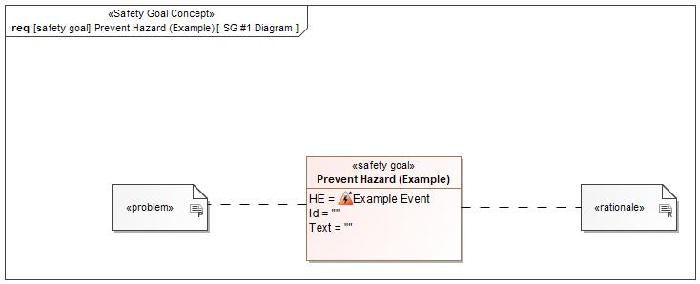

Figure 1: SG #1 Diagram – Prevent Hazard (Example)

*Note: The authoritative source for the Safety Goals is document “FFSD 02 Hazard Analysis* *and Risk Assessment”. The documentation of Safety Goals in this chapter (In the Argumentation for Safety Goal achievement) is for information purposes only.*

*The authoritative source for the Functional Safety Requirements is section 2.1.x.3: of this document. The documentation of Functional Safety Requirements in the following chapter (complete or summarised) is for information purposes only.*

#### Warning and Recovery Concept

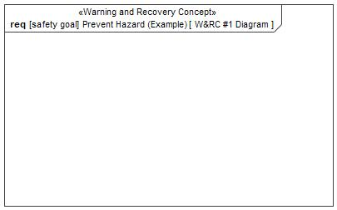

Figure 7: W&RC #1 Diagram – Prevent Hazard (Example)

#### FSRs for - Prevent Hazard (Example)

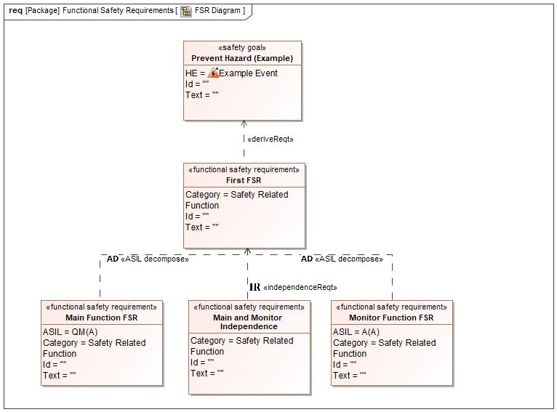

Figure 1. Prevent Hazard (Example)

Main and Monitor Independence

Satisfied by:

* Logicals:
  + Controller

Related to:

* Safe States:
  + Safe State #1
* Operating Modes:
  + System Enabled

|  |  |  |  |  |  |  |  |
| --- | --- | --- | --- | --- | --- | --- | --- |
| Requirement ID: | | | | | | | |
| **Purpose** |  | | | | | | |
| **V&V Acceptance Criteria** |  | | | | | | |
| **Notes** |  | | | | | | |
| **Source** |  | | | | | **Owner** |  |
| **Source Req.** | * 564033544.jpg Prevent Hazard (Example) | | | | | **V&V Method** |  |
| **Type** | N/A | | **Priority** | | N/A | **Status** |  |
| **ASIL** |  | | **Category** | | Safety Related Function | **Fault Handling Time** | N/A |
| [Req. Template](http://wiki.ford.com/display/RequirementsEngineering/Requirements+Attributes) Version | | 6.0 | | End of Requirement | | | |

Main Function FSR

Satisfied by:

* Logicals:
  + Controller

Related to:

* Safe States:
  + Safe State #1
* Operating Modes:
  + System Enabled

|  |  |  |  |  |  |  |  |
| --- | --- | --- | --- | --- | --- | --- | --- |
| Requirement ID: | | | | | | | |
| **Purpose** |  | | | | | | |
| **V&V Acceptance Criteria** |  | | | | | | |
| **Notes** |  | | | | | | |
| **Source** |  | | | | | **Owner** |  |
| **Source Req.** | * 564033544.jpg Prevent Hazard (Example) | | | | | **V&V Method** |  |
| **Type** | N/A | | **Priority** | | N/A | **Status** |  |
| **ASIL** | QM(A) | | **Category** | | Safety Related Function | **Fault Handling Time** | N/A |
| [Req. Template](http://wiki.ford.com/display/RequirementsEngineering/Requirements+Attributes) Version | | 6.0 | | End of Requirement | | | |

First FSR

Satisfied by:

* Logicals:
  + Actuator

Related to:

* Safe States:
  + Safe State #1
* Operating Modes:
  + System Enabled

|  |  |  |  |  |  |  |  |
| --- | --- | --- | --- | --- | --- | --- | --- |
| Requirement ID: | | | | | | | |
| **Purpose** |  | | | | | | |
| **V&V Acceptance Criteria** |  | | | | | | |
| **Notes** |  | | | | | | |
| **Source** |  | | | | | **Owner** |  |
| **Source Req.** | * 564033544.jpg Prevent Hazard (Example) | | | | | **V&V Method** |  |
| **Type** | N/A | | **Priority** | | N/A | **Status** |  |
| **ASIL** |  | | **Category** | | Safety Related Function | **Fault Handling Time** | N/A |
| [Req. Template](http://wiki.ford.com/display/RequirementsEngineering/Requirements+Attributes) Version | | 6.0 | | End of Requirement | | | |

Monitor Function FSR

Satisfied by:

* Logicals:
  + Controller

Related to:

* Safe States:
  + Safe State #1
* Operating Modes:
  + System Enabled

|  |  |  |  |  |  |  |  |
| --- | --- | --- | --- | --- | --- | --- | --- |
| Requirement ID: | | | | | | | |
| **Purpose** |  | | | | | | |
| **V&V Acceptance Criteria** |  | | | | | | |
| **Notes** |  | | | | | | |
| **Source** |  | | | | | **Owner** |  |
| **Source Req.** | * 564033544.jpg Prevent Hazard (Example) | | | | | **V&V Method** |  |
| **Type** | N/A | | **Priority** | | N/A | **Status** |  |
| **ASIL** | A(A) | | **Category** | | Safety Related Function | **Fault Handling Time** | N/A |
| [Req. Template](http://wiki.ford.com/display/RequirementsEngineering/Requirements+Attributes) Version | | 6.0 | | End of Requirement | | | |

### Derivation of Functional Safety Requirements on Assumptions

**#Classification**: Functional Safety only

**#Hint:** Derive requirements from the Assumptions (refer to section “Safety Assumptions”

No Functional Safety Requirements tracing to Assumptions specified.

## ASIL Decomposition of Functional Safety Requirements

***#Classification:*** *Functional Safety Only*

***#Hint:*** *For ASIL D features additional measures like a requirements decomposition might be required. Fill out the following table for each ASIL D decomposition applied in the feature. The decomposition rationale is the reason why the decomposition was performed, whereas the rationale for each requirement expresses the reason and thought behind that particular requirement and should include how the requirement is able to independently fulfill the needs of the parent requirement.*

***#Link:***[*Functional Safety Sharepoint*](https://pd3.spt.ford.com/sites/GlobalFunctionalSafety/Pages/default.aspx) *- Functional Safety Concept*

### Decomposition of Functional Safety Requirement

| Initial Safety Requirement | First FSR | |
| --- | --- | --- |
| Decomposition Rationale |  | |
| Method for Decomposition | A -> A(A) + QM(A) | |
| Functional Safety Requirement 1 after Decomposition | F-S-Req-ID |  |
| F-S-Req. Title | Main Function FSR |
| ASIL | QM(A) |
| Rationale |  |
| Satisfied by | * Controller |
| Functional Safety Requirement 2 after Decomposition | F-S-Req-ID |  |
| F-S-Req. Title | A(A) |
| ASIL | Monitor Function FSR |
| Rationale |  |
| Satisfied by | * Controller |
| Functional Safety Requirement for Independence | F-S-Req.-ID |  |
| F-S-Req. Title | Main and Monitor Independence |
| ASIL |  |
| Rationale |  |

# Architecture

## Functional Architecture

**#Classification:** Mandatory for Functional Safety – otherwise optional

**#Hint**: This section depicts the coarse Functional Architecture. This architectural step is needed to find the right functional partitioning for the function level. The function shown here are those, which are specified on function level. Either SysML activity diagrams or Data Flow Diagrams could be used to depict such a Functional Architecture. For bigger features, which are decomposed in a hierarchical manner down to atomic functions (and which do not follow the Functional Safety process), a function tree could be given here.

**#Links:**

* Functional Decomposition: [RE Wiki – Functional Decomposition](http://wiki.ford.com/display/RequirementsEngineering/Functional+Decomposition)
* SysML - Activity Diagrams or [RE Wiki - Data Flow Diagrams](http://wiki.ford.com/display/RequirementsEngineering/Data+Flow+Diagram?src=contextnavpagetreemodehttp://wiki.ford.com/display/RequirementsEngineering/Data+Flow+Diagram?src=contextnavpagetreemode)
* Data Flow Diagram: [RE Wiki – Data Flow Diagram](http://wiki.ford.com/display/RequirementsEngineering/Functional+Decomposition)

Description of the diagram and content about Functional Architecture in Documentation field of Functional Boundary Diagram.

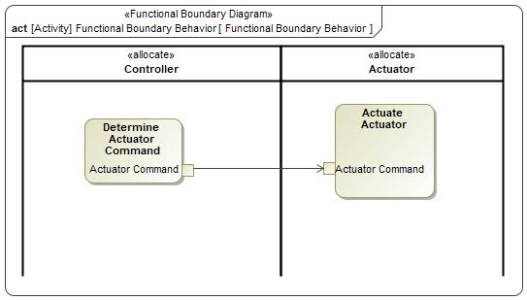

Figure 8: Functional Boundary Behavior

### List of Functions

**#Hint:** The functions shown in the Functional Architecture should be listed and described in the table below

| **Function Name** | Description | Comments |
| --- | --- | --- |
| *(action)* Actuate Actuator | *(action)* The Command Gearbox State function commands the Gearbox using the Range Command using the Range Desired and Sensed State of the Gearbox. |  |
| *(action)* Determine Actuator Command | *(action)* The Range to Select function receives the Range Requested and then determines the proper Range Desired based on vehicle conditions (for example: vehicle speed). |  |

Table 16: List of Functions

## Logical Architecture

**#Classification:** Functional Safety Analysis only

**#Hint:** FS Analysis requires a description of the boundary of the feature and its elements. A simple block diagram or a SysML Internal Block Diagram could be used to depict the Logical Architecture

***#Link:*** [*Ford Functional Safety Sharepoint*](https://pd3.spt.ford.com/sites/GlobalFunctionalSafety/Pages/default.aspx)

Description of diagram and content on logical architecture in Documentation field of Structural Boundary Diagram.

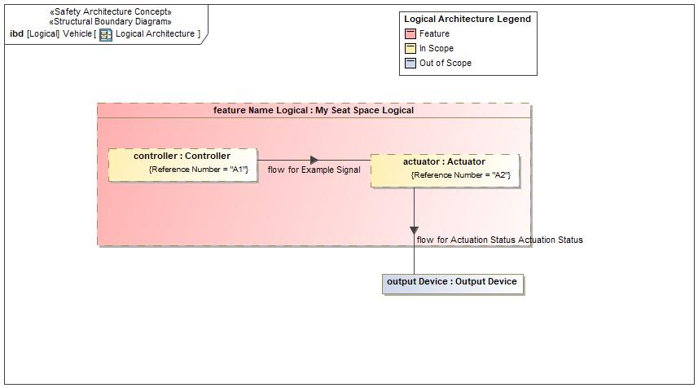

Figure 9: Logical Architecture

### Logical Elements

**#Hint:** Lists the elements of the Logical Architecture and the functions from the Functional Architecture, which are allocated to those elements.

|  |  |  |  |
| --- | --- | --- | --- |
| **Element Name** | **Description** | **Allocated Functions** | **Comments** |
| Actuator |  |  |  |
| Controller |  |  |  |
| My Seat Space Logical |  |  |  |
| Output Device |  |  |  |

Table 19: Logical Elements

### Logical Interfaces

**#Hint:** Describe the interactions of the feature with other features or elements.

|  |  |  |  |
| --- | --- | --- | --- |
| **Interface** | **Direction** | **Description** | **Value Range** |
| Actuation Status | Actuator To Output Device |  |  |
| Example Signal | Controller To Actuator | The description of the signal in the Documentation field. |  |

Table 18: Feature Interactions

# Open Concerns

**#Hint:** The following list presents open concerns, which have to be discussed or clarified over the course of the on-going requirements engineering.

| ID | Concern Description | e-Tracker / Reference | Responsible | Status | Solution |
| --- | --- | --- | --- | --- | --- |
| 1 |  |  |  |  |  |

Table 20: Open Concerns *(Not supported by MagicDraw report generation)*

# Revision History

**#Hint:** A new version number is assigned to a document with a given revision each time it is checked in to Team Center (TCSE). After release of a revision, the document cannot be edited and no new versions can be created on that revision. When updating the document after that, a new revision has to be created and new versions on that revision will be created upon checking in.

No Revision History found.

## Template Revisions

*#Important: Do not change this section*

|  |  |  |  |  |
| --- | --- | --- | --- | --- |
| Version | Rev. | Date | Description | Responsible |
| *0* | *6* | *2015-05-26* | * *Chapter “Feature Overview” and made a 2nd level heading.* * *Chapter “Feature Modeling” divided into 3 subchapter (“Scenarios”, “Use Cases”, “State Machines”) for different modeling methods* | *Jbaden1* |
| *0* | *7* | *2015-05-27* | * *Table of Content updated* * *Template Revision History chapter added* | *Jbaden1* |
| *0* | *8* | *2015-07-02* | * *Section “Unsettled Issues” added* | *Alevin7* |
| *0* | *9* | *2015-08-04* | * *Section “Feature Variants” added* * *Section “Feature Boundary Diagram” renamed to “Feature Context Diagram”* * *Document Properties adapted to match needs of VBA macros* | *Jbaden1, Awegman1* |
| *1* | *0* | *2015-09-11* | * *Section “Feature Variants” reworked* * *Feature Goals removed. Only “Safety Goals“ chapter remains.* * *Heading 2 formatting issues corrected.* * *Requirements / Use Cases Listing removed from traceability chapter.* * *Formatting of attribute table in Notation chapter corrected* * *Open Topics / Known Issues chapter moved to the end* | *Jbaden1* |
| *1* | *1* | *2015-11-16* | * *Table-Styles removed (for smooth VSEM import)* * *Some clean-up of sections “Purpose” and “Audience”* | *Awegman1, jbaden1* |
| *1* | *2* | *2016-02-26* | * *Minor corrections based on lessons learned from CC and PCL pilot (e.g. section market/regions) and discussion with Functional Safety Team (purpose of feature)* * *Footer corrected* * *Boundary diagram interface chapter renamed to influences.* | *Jbaden1* |
| *1* | *3* | *2016-02-26* | * *Minor corrections after review with Whitney Keith from Functional Safety team* | *Jbaden1* |
| *1* | *4* | *2016-03-10* | * *Some cleanup of meta-data in Word Properties* | *Jbaden1* |
| *1* | *5* | *2016-03-10* | * *Footer formatting corrected (Issue 19)* * *Results from review with Functional Safety Team incorporated (Issue 20).* | *jbaden1* |
| *1* | *6* | *2016-04-18* | * *Scenario Template added* | *Jbaden1* |
| *1* | *7* | *2016-04-18* | * *Chapter “Operation Modes and States” moved before “Use Case” section.* | *Jbaden1* |
| *1* | *8* | *2016-04-18* | * *Broken Wiki links repaired.* | *Jbaden1* |
| *2* | *0* | *2016-05-19* | * *Adapted to Specification_Macros.dotm V2.0* * *Requirements Templates chapter (ch. 1.7.1) no longer has an attribute table, but refers directly to the Wiki..* | *Jbaden1* |
| *2* | *1* | *2016-06-10* | * *Table for Context Diagram modified (lists external entities and Influence Description only)* | *Jbaden1* |
| *2* | *2* | *2016-07-08* | * *Template version added to footer* * *Several hints added to the various sections* * *Findings from Functional Safety Team incorporated.* * *RE_SafetyRequirement style added* | *Jbaden1* |
| *2* | *3* | *2016-09-21* | * *Update from Functional Safety Team incorporated (“Lessons Learned”, “System Behaviors for HARA”)* | *Jbaden1* |
| *2* | *4* | *2016-11-15* | * *Update from Functional Safety Team incorporated (“Lessons Learned”, “System Behaviors for HARA”)* * *Explanatory notes made more formal* | *Jbaden1* |
| *3* |  |  | *Skipped to synchronize with Specification_Macros.dotm* |  |
| *4* |  |
| *5* | *0* | *2017-01-13* | * *Meta data updated for specification macros, version 3.1* * *SW Unit chapter removed for the time being* * *Green boxes added for user hints* | *Jbaden1* |
| *5* | *1* | *2017-01-18* | * *Minor editorial changes* | *Jbaden1* |
| *6* | *0* | *2017-02-03* | * *CR48: Chapter 6 renamed from “Safety” to “Functional Safety”. New sub-chapter “Safety” introduced in Non-Functional Requirements section* | *Jbaden1* |
| *6* | *0* | *2017-04-28* | * *CR7: “RequirementsTraceability” chapter removed* | *Jbaden1* |
| *6* | *0* | *2017-11-15* | * *CR32/53: New Cover Sheet + Disclaimer replaces FAP-150 like ones.* * *CR75: Some rewording -> Terminology to Glossary, Notation -> Document Conventions* * *CR49: Rename “Assumptions & Constraints” to “Assumptions”* * *CR74: Safety Assumptions added to chapter 6.* * *CR58: Add function allocation column to Logical Architecture chapter* | *Jbaden1* |
| *6* | *0* | *2018-01-31* | * *CR63: Updated links to Functional Safety Sharepoint* | *Jbaden1* |
| *6* | *0* | *2018-07-24* | * *CR69: Add FSR to FeatureDoc* * *CR64: Add new section "Design Requirements" to Function Spec and Feature Spec* | *Jbaden1* |
| *6* | *0* | *2018-08-06* | * *CR53: some corrections for metada and formatting* | *Jbaden1* |
| *6* | *0* | *2018-09-28* | * *Broken links to RE Wiki repaired* | *Jbaden1* |
| *6* | *0* | *2018-10-31* | * *Cover sheet and footer more GIS like. Functional Safety team feedback incorporated:*   + *New subsections “Functional Safety Requirements, (Decomposed) FSRs and Parameters / Values*   + *Removal of “Logical Architecture”* | *Jbaden1* |
| *6* | *0* | *2018-12-12* | * *FSR template removed, now as a macro in the Specification_Macros.dotm* | *Jbaden1* |
| *N* |  | *2019-04-03* | * *Updated code for context diagrams, actors and use cases.* * *Updated code structure with all macros at the beginning.* * *Updated code to populate assumptions using element-assumption relationship or hazardous event.* | *snuesch* |
| *N* |  | *2019-04-18* | * *Added structural boundary diagram for FuSa based on TGB discussion.* * *Added operating modes to functional safety requirements.* | *snuesch* |
| *N* |  | *2019-04-25* | * *Improved export of actions and activities on functional boundary diagram.* | *snuesch* |
| *6* | *0b* | *2019-05-23* | * *Re-introduce “Logical Architecture” (for Functional Safety)* | *Jbaden1* |
| *N* |  | *2019-06-17* | * *Aligned “Architecture” section with RE template.* * *Made “Ford Documents” table more flexible.* * *Added template terms to glossary* | *snuesch* |
| *N* |  | *2019-06-25* | * *Improved use cases to handle Primary and Secondary actors.* * *Added Performance Requirements to Uncategorized.* | *snuesch* |
| *6* | *0b* | *2019-06-26* | * *Chapter “Logical Elements” in “Logical Architecture” section added (FuSa CR 15136240)* * *“References” and “Glossary” chapter moved from section “Feature Overview” to “Introduction”. References and Glossary should be available in the document as early as possible* | *Jbaden1* |
| *N* |  | *2019-07-25* | * *Added populated “Logical Elements” table and allocated functions.* * *Export documentation field of context diagram.* | *snuesch* |
| *N* |  | *2019-08-09* | * *Export documentation field of use case diagram.* * *Fixed bug in Feature Requirement Verification Method.* * *Simplified export of References without publisher.* | *snuesch* |
| *N* |  | *2019-08-21* | * *Improved glossary and acronym tables* | *snuesch* |
| *N* |  | *2019-08-28* | * *Fixed bug in populating title in header* | *snuesch* |
| *N* |  | *2019-09-16* | * *Updated bibliography export* | *snuesch* |
| *N* |  | *2019-09-27* | * *Updated export of Verification Method and Requirement Status for Feature Requirements and V&V Method for Functional Safety Requirements.* | *snuesch* |

# Appendix

## Definitions

| **Definition** | **Description** |
| --- | --- |
| sound zone | The audio capable components and functionality for each individual seat. The speakers, microphone, and available HMI for each seat constitutes its sound zone. A sound zone is capable of streaming its own content separate from the other sound zones. |

Table 21: Definitions used in this document

## Abbreviations

| **Abbr.** | **Stands for** |
| --- | --- |
| DND | Do Not Disturb |
| ICC | In Car Communication |
| MSS | My Seat Space |
| VSP | Video Streaming Platform |

Table 22: Abbreviations used in this document

Document ends here.